The Voluntary National Review – should New Zealand celebrate or despair?

New Zealand’s first report to the United Nations on our progress against the Sustainable Development Goals – the Voluntary National Review (VNR) – provides insight into some of the work to date, and the huge challenges our nation faces to meet the Agenda 2030 targets*.

The NZ VNR report will be presented to the United Nations at the High Level Political Forum on Sustainable Development on 18 July 2019.

It will also be a key stream of discussion at the upcoming NZ Sustainable Development Goals Summit 2019.

Sustainable intergenerational wellbeing
In her forward to the report, Prime Minister Jacinda Ardern notes the review covers all 17 SDGs with a national lens.
“The report highlights challenges as well as successes, provides a baseline for future reporting, and identifies areas where more work needs to be done.
“New thinking is needed to achieve the vision captured within the SDGs. Rather than measuring progress in purely economic terms, the New Zealand Treasury is developing a broader set of measures – the Living Standards Framework based on work done by the OECD – that puts sustainable intergenerational wellbeing at the centre of policy-making and the management of our resources,” says the PM.

The report acknowledges the Treaty of Waitangi, status of Māori as tangata whenua and its profound importance to New Zealand. Our unique position in the Pacific is also noted.

SDG Challenges identified

SDG1 No Poverty
- The proportion of New Zealand households experiencing poverty or material hardship (and over-representation of Māori, Pacific and those with disabilities in these numbers).
- Child poverty and its impact on individuals’ future wellbeing and happiness.
SDG2 Zero Hunger
- The challenge of climate change for our globally significant agriculture systems.
- Tackling agricultural emissions
- Obesity
- Māori-owned land productivity

SDG3 Good Health and Wellbeing
- Health and wellbeing inequalities between sub-populations.
- Burden of disease from non-communicable diseases, mental health and tobacco use.
- True access to universal healthcare.
SDG4 Quality Education
- Equity of educational outcomes for Māori and Pacific students and those with disabilities and learning support needs.
- Increasing pressure on the supply of teachers.
- A devolved school governance system
SDG5 Gender Equality
- The national gender pay gap of 9.2%.
- Violence against women.
- Representation on private sector boards.
- Women’s access to justice and health care.
SDG6 Clean Water and Sanitation
- Reducing key sources of pollution
- Community engagement in integrated catchment planning and the management of water services.
- Protecting and restoring water ecosystems.
- Loss of natural wetlands.
- Equitable access to safe and affordable drinking water.
SDG7 Affordable and Clean Energy
- Only 11% of NZ final energy consumption from renewable energy sources and 20% higher energy intensity than OECD average.
- Industry, manufacturing, transport and agriculture sectors’ reliance on fossil fuels.
- Negligible impact of NZ Emissions Trading Scheme (NZ ETS)
SDG8 Decent Work and Economic Growth
- Preparing for and making the most of changes due to technology, digitalisation, the internet of things, clean energy and the sharing economy, as well as global disruptions.
- Low productivity levels relative to the OECD.
- Economic growth’s pressure on New Zealand’s biophysical limits, infrastructure and social outcomes.
SDG9 Industry, Innovation and Infrastructure
- Relatively low levels of productivity growth and investment in large-scale infrastructure.
- Institutional settings to support infrastructure outcomes at a local level.
- Challenge of expanding mobile and broadband coverage to rural New Zealand.
- A notably small science and innovation system and investment in research and development.
SDG10 Reduce Inequalities
- National income share of bottom 40% of population unchanged since 1996.
- Need to focus on sole parent households, those of the elderly living alone, Māori and Pacific households.
- Temporary migrant worker exploitation.
SDG11 Sustainable Cities and Communities
- Competing challenges of accommodating growing populations, managing urban expansion and preserving the natural environment.
- Hazards from natural disasters.
SDG12 Sustainable Consumption & Production
- Maintaining community-agreed ecological limits for freshwater quality and mitigating agricultural greenhouse gases while maintaining our export-led economy.
- Waste disposed to landfills and generation of household waste.
- Ensuring tourism activity is carried out in harmony with sustainable development objectives.
SDG13 Climate Action
- Continuing to produce food efficiently for a growing global population, reduce emissions and enable rural communities to adapt to climate change.
- Growth of emissions from transport linked to private vehicles and low use of public transport.
- Creating a system more reflective and representative of Māori interests to help mitigate the impacts of climate change felt by Māori.
SDG14 Life Below Water
- Cross jurisdictional management limiting ability to report on restoring and strengthening the resilience of marine and coastal ecosystems.
- Lack of data on scale of polluting activities (e.g. farming and forestry).
SDG15 Life on Land
- Changing land use and the impacts of invasive species.
- Maintaining the balance between protected areas of forests and privately owned production forests.
- Outdated and numerous statures governing terrestrial conservation management.
SDG16 Peace, Justice and Strong Institutions
- Access to justice and participation in democracy for all New Zealanders.
- Levels of family and sexual violence.
- Overrepresentation of Māori in the country’s prison population.
- High rates of imprisonment and reoffending.
SDG17 Partnerships for the Goals
- Scale of finance required by developing countries.
- Trade being hindered by a rise in protectionist policies.

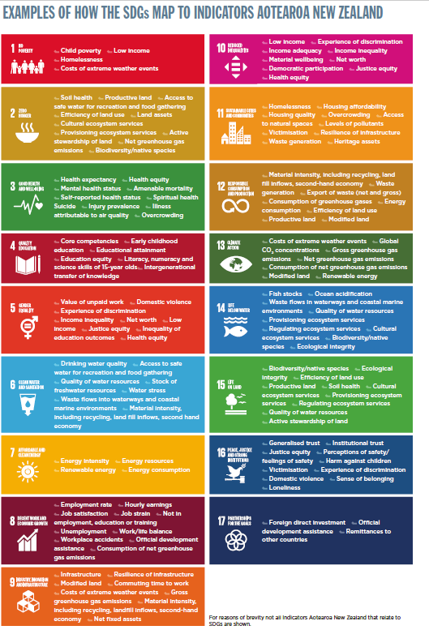

*The SDGs establish a universal agenda for action to achieve sustainable development globally. The new Goals integrate the three dimensions of sustainable development (economic, social and environmental) and are applicable to all countries.
In September 2015, United Nations Member States signed up to a universal set of 17 Sustainable Development Goals (SDGs) and 169 targets (Agenda 2030).

